# PROJECT - CUSTOMER RELATIONSHIP MANAGEMENT (CRM)

# 

# DONE BY,

# INDHU R V

**INTRODUCTION :**

# What is CRM ?

CRM stands for Customer Relationship Management. It refers to a strategy and a set of practices, technologies, and systems that businesses use to manage and analyze customer interactions and data throughout the customer lifecycle, with the goal of improving customer service relationships and assisting in customer retention and sales growth.

A CRM system helps businesses manage their interactions with current and potential customers. It typically involves collecting customer data from various sources, such as email, telephone calls, social media, and website visits, and consolidating it into a centralized database. This data can include contact information, purchase history, preferences, and any other relevant details.

# PURPOSE OF CRM :

The purpose of CRM (Customer Relationship Management) is multifaceted, aiming to enhance the overall customer experience and improve business operations. Here are some key purposes:

* **Customer Data Management**
* **Improved Customer Service**
* **Sales Enablement**
* **Marketing Optimization**
* **Customer Insights and Analytics**
* **Enhanced Collaboration**
* **Customer Retention and Loyalty**
* **Business Growth and Profitability**

# Now , our project is to download customer data in csv format

# A CSV (Comma-Separated Values) file is a plain text file format used to store tabular data, such as spreadsheets or databases. In a CSV file, each line of the file corresponds to a row of the table, and the values within each row are separated by commas (hence the name).

# Let's create a simple CRM (Customer Relationship Management) project in Python that allows users to download customer data in CSV format

# Creating a CRM (Customer Relationship Management) project to download customer data in CSV format involves several steps. Here's a step-by-step

# STEP 1:

There are numerous CRM (Customer Relationship Management) platforms available online, each offering a variety of features and tailored solutions to suit different business needs. Some of the popular CRM platforms include: **Salesforce,** HubSpot sales CRM , **Zoho CRM,** **Microsoft Dynamics 365 etc**

We are choosing HubSpot sales CRM platform

Firstly, to access customer data in HubSpot Sales CRM .

You can do that by the following steps:

1. **Log in to HubSpot**:
   * Go to the HubSpot website and log in to your HubSpot Sales CRM account using your credentials.

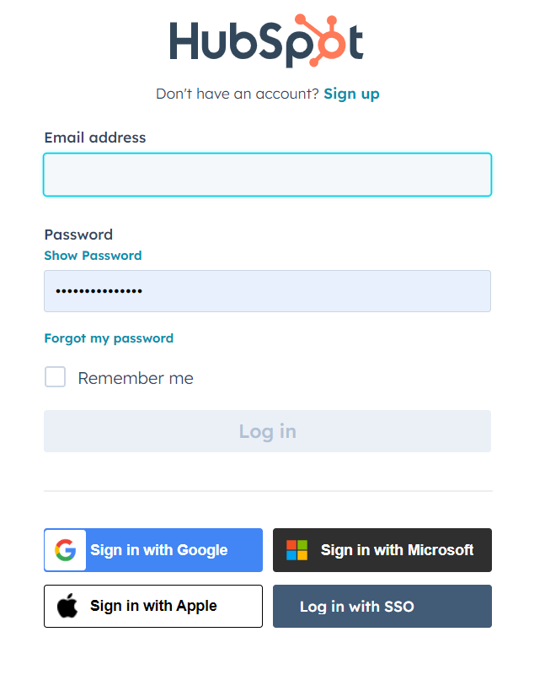

1. **Navigate to Contacts**:
   * Once logged in, navigate to the "Contacts" section in the HubSpot dashboard. You can find it in the left sidebar menu.
2. **View Contact Records**:
   * In the Contacts section, you'll see a list of all your contacts. You can scroll through the list or use the search bar to find specific contacts.

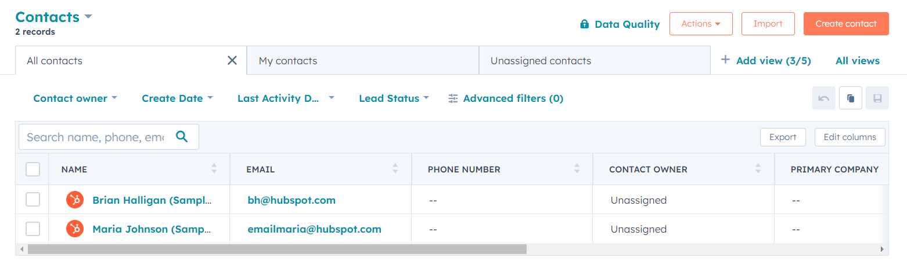Click on a contact's name to view their contact record. Here, you'll find details such as name, email address, phone number, company, and any other

**4. Export Contacts**:

* To export contacts, select the contacts you want to export by checking the checkboxes next to their names.
* Click on the "Actions" dropdown menu and select "Export". Choose the export format (CSV) and follow the prompts to download the exported file.

**STEP 2: Setting Up the Project Structure**

Create a new directory for your project. Inside this directory, create the following files:

1. **app.py**: This will contain the main Flask application.
2. **templates/**: This directory will hold the HTML templates.

**STEP 3: Writing the Flask Application (app.py)**

Open **app.py** in your text editor and write the following code:

# 

### **STEP 4: Creating HTML Template**

Create a file named **index.html** inside the **templates/** directory. This file will contain the HTML template to display customer data and provide a link to download the CSV file. **Download CSV Route:**

* When accessing the **/download-csv** route, the application dynamically generates a CSV file named **customer_data.csv**

# 

### **STEP 5: Running the Application**

Open a terminal, navigate to your project directory, and run the Flask application by executing **python app.py**.

### **STEP 6 : Accessing the Application**

Open a web browser and go to **http://localhost:5000**. You should see a list of customer data along with a link to download the CSV file

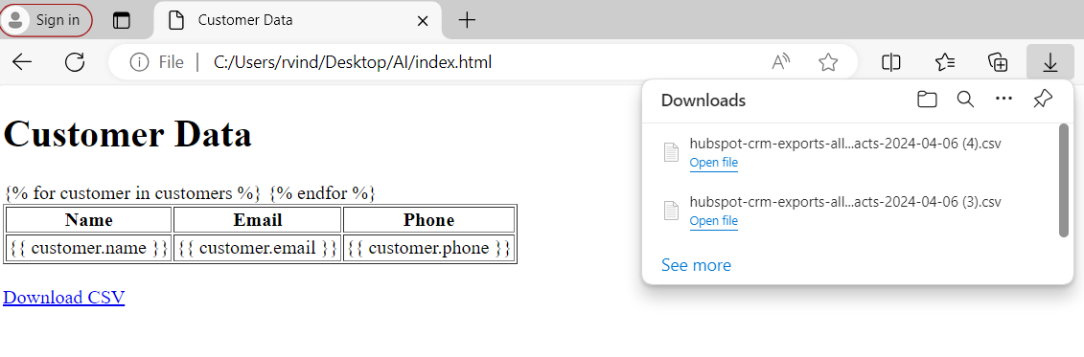

**STEP 7 : Output**

Opening the downloaded CSV file should display the customer data in CSV format, with headers for name, email, and phone, and each row representing a customer's information.

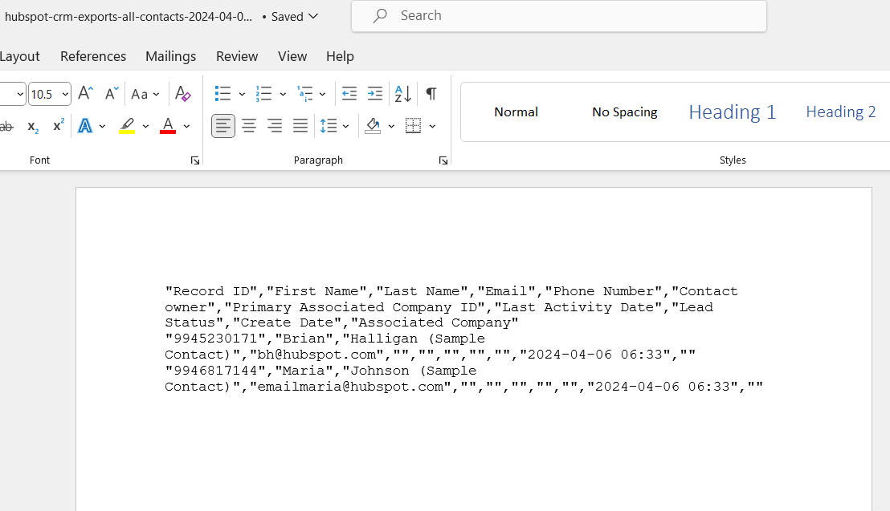

**FILE**: I am Adding the Github repository link for this project here : <https://github.com/rvindhu/AI-INTERN>

**CONCLUSION:**

Hence, we have successfully created a simple CRM (Customer Relationship Management) project in Python that allows users to download customer data in CSV format using visual code idle .

In conclusion, the CRM project we've developed leverages Flask, a lightweight web framework in Python, to efficiently manage and present customer data. By providing a seamless interface for users to access and download data in CSV format, it enhances user experience and facilitates data utilization. With clear routes for data access and download, the application ensures simplicity and effectiveness. By continually refining and expanding the functionality, this CRM project can evolve to meet the evolving needs of businesses.